**AWS ADDITIONAL INFORMATION**

🡪In our local system (While using vm), above windows we launch multiple vms.

🡪For launching vms, we use program(layer) known as hypervisor (Vbox in our case).

🡪In aws name of hypervisor is Xen.

🡪But here hypervisor = layer + linux OS

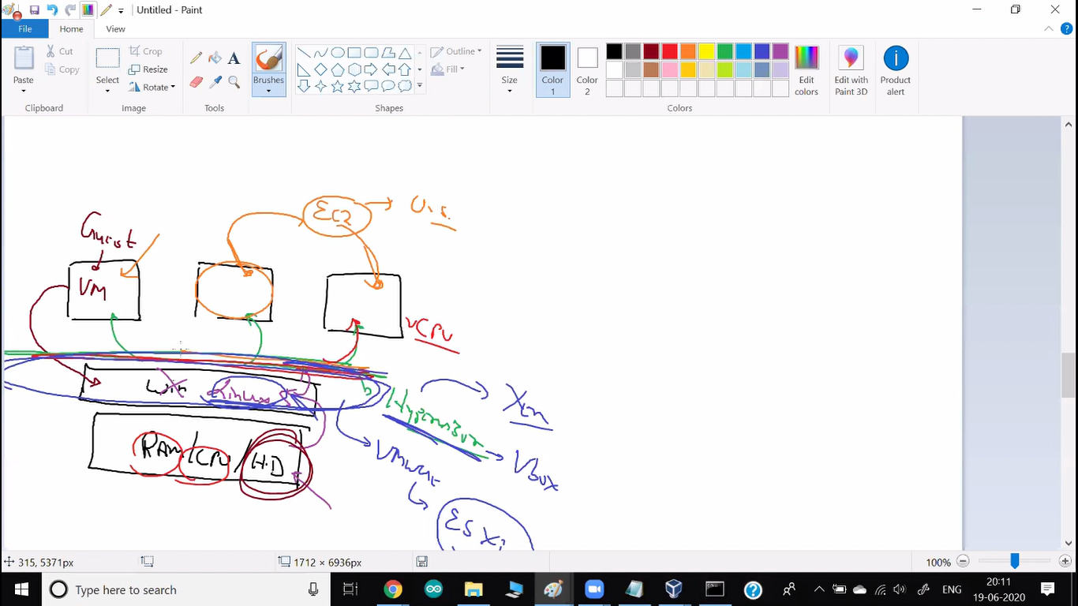

**Emphremal Storage**

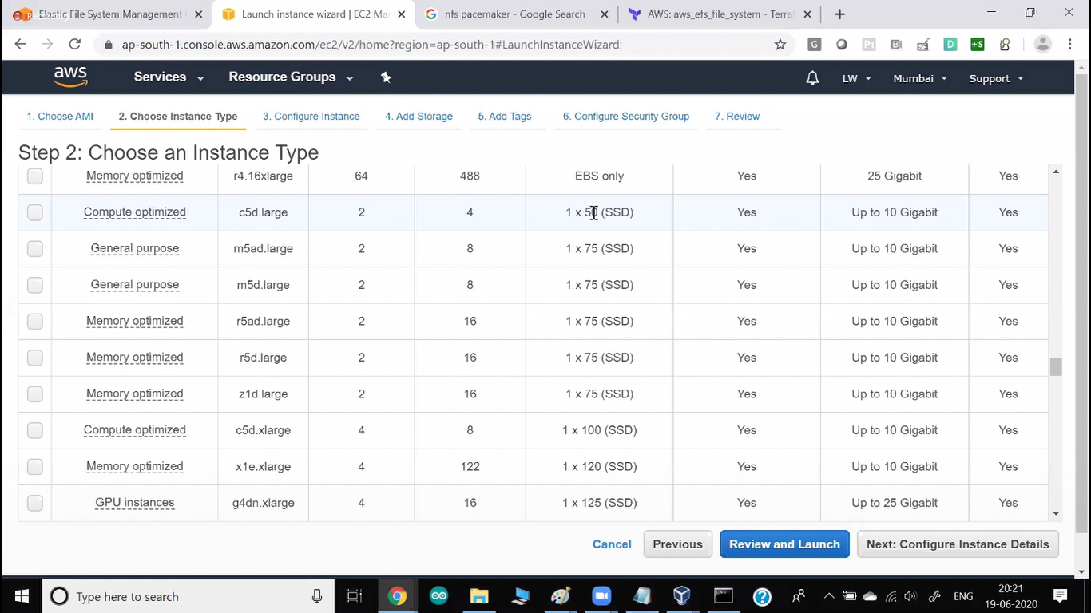

🡪Here this c5d.large (it is not EBS) are using your local system.  
🡪But here whenever your system shut down your complete data will be deleted.

🡪We use this system in big data world.

🡪We don’t concern about our data is permanent or not, but we are concerned about speed.  
🡪It is in our local system. So, read write operations are faster.  
🡪Because they don’t have to go to EBS and transfer data using networking every time.